SIMATS ENGINEERING – C01(Assessment Tool 2)
Concept Mapping

Name: Siva Dakshitha K Reg.No: 192425395
Course Code: CSA0703 Course: Computer Networks

1. Complete the Concept Map

Concept Map:

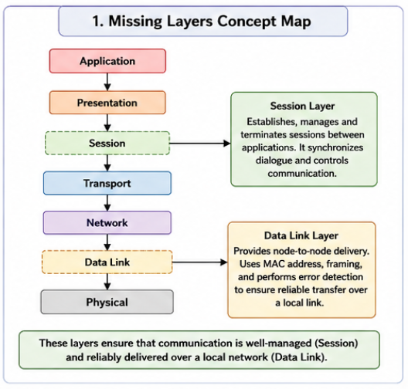

Analysis:

- Session Layer
  - Establishes, manages, and terminates communication sessions.
  - Keeps communication synchronized between sender and receiver.
- Data Link Layer
  - Transfers data between directly connected devices.
  - Detects transmission errors using error detection methods.
  - Uses MAC addresses for local communication.

Conclusion:

The Session Layer ensures continuous communication, while the Data Link Layer provides reliable local data transfer. Together, they support reliable end-to-end communication.

2. Concept Map for Data Units and OSI Layers

Concept Map:

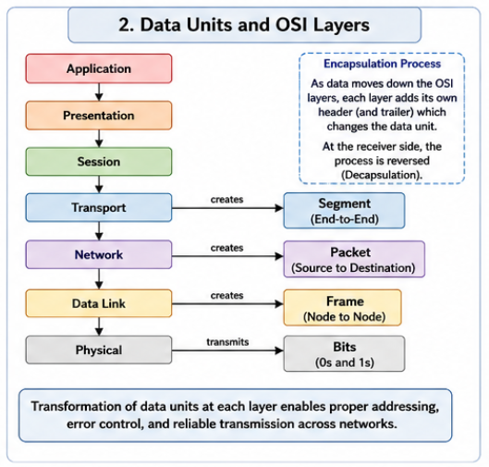

Analysis:

OSI Layer | Data Unit | Function
Transport | Segment | Divides data for transmission
Network | Packet | Adds IP address for routing
Data Link | Frame | Adds MAC address and error checking
Physical | Bits | Converts data into electrical or optical signals
Conclusion:

During transmission, data changes from Segment → Packet → Frame → Bits. Each layer adds its own information (encapsulation), ensuring reliable communication.

3. MAC Address and IP Address Concept Map

Concept Map:

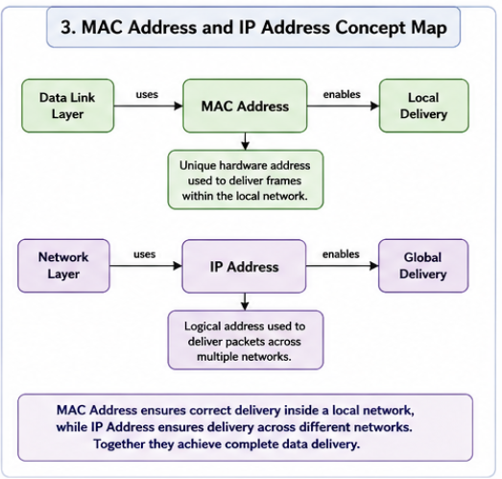

Analysis:

- MAC Address
  - Used for communication inside the same local network.
  - Identifies the physical device.
- IP Address
  - Used to send data between different networks.
  - Identifies the destination network and host.
Conclusion:

The Data Link Layer ensures correct local delivery using MAC addresses, while the Network Layer ensures global delivery using IP addresses. Together they provide complete communication.

4. Error Control Concept Map

Concept Map:

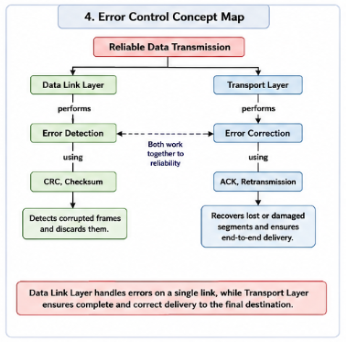

Analysis:

- Data Link Layer
  - Detects transmission errors using CRC or checksum.
  - Prevents corrupted frames from being accepted.
- Transport Layer
  - Detects missing segments.
  - Uses acknowledgements (ACK) and retransmission to recover lost data.
Conclusion:

Both layers work together to improve reliability. The Data Link Layer detects errors locally, while the Transport Layer ensures complete and correct end-to-end delivery.

5. Web Browsing Using OSI Layers

Concept Map:

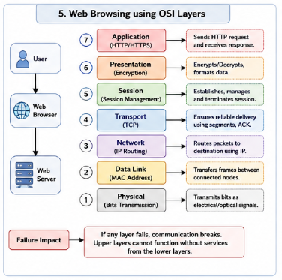

Analysis:
Layer | Role in Web Browsing
Application | Sends HTTP request
Presentation | Encrypts and formats data
Session | Maintains communication session
Transport | Ensures reliable delivery using TCP
Network | Routes packets using IP
Data Link | Sends frames within local network
Physical | Transmits bits over cable or Wi-Fi
Failure Analysis:

If any layer fails:
- Physical failure → No signal.
- Data Link failure → Frames cannot reach the next device.
- Network failure → Packets cannot reach destination.
- Transport failure → Data becomes incomplete.
- Application failure → Website cannot be displayed.
Conclusion:

Every OSI layer depends on the previous one. Failure of one layer affects the entire communication process.

6. Troubleshooting Using Concept Map

Concept Map:

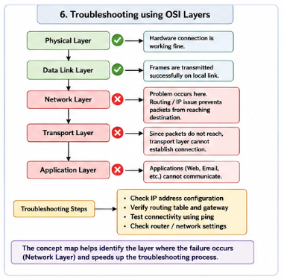

Analysis:

- Physical Layer is working.
- Data Link Layer is working.
- Network Layer has failed.
- Since routing fails, packets cannot move to other networks.
- Therefore, the Transport Layer cannot establish communication.
- Finally, the Application Layer cannot access services such as websites or email.
Troubleshooting Steps:

- Check IP configuration.
- Verify router connectivity.
- Test using ping.
- Check routing tables.
- Verify gateway settings.

Conclusion:

The concept map quickly identifies that the problem starts at the Network Layer. Since upper layers depend on lower layers, all higher layers also fail. This helps troubleshoot the network efficiently.

